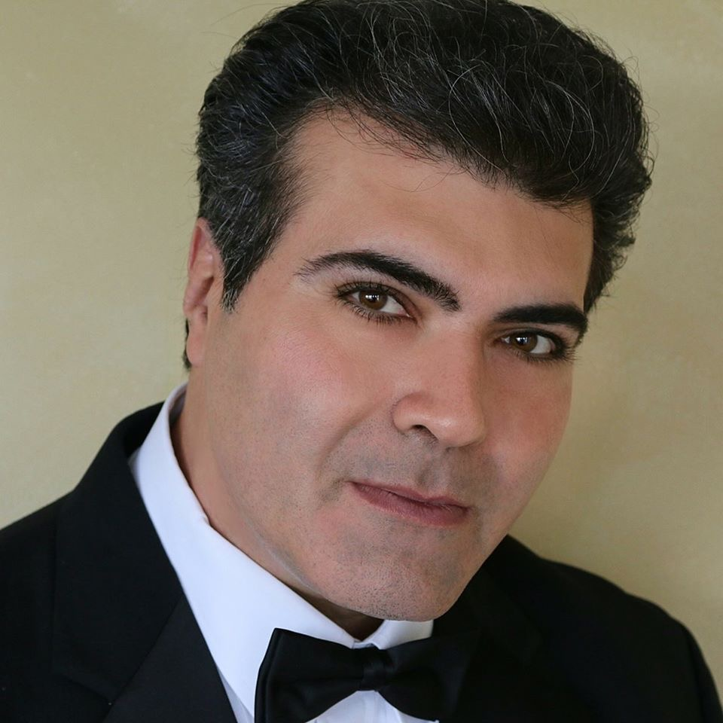
(b. 1966) Samuel R. Hazo resides in Pittsburgh, Pennsylvania with his wife and children. In 2003, Mr. Hazo became the first composer in history to be awarded the winner of both composition contests sponsored by the National Band Association. His piece Mountain Thyme was an Honorable Mention for the 2013 CBDNA Composition Contest. He has composed for the professional, university and public school levels in addition to writing original scores for television, radio and the stage. His original symphonic compositions include performances with actors Brooke Shields, James Earl Jones, and Richard Kiley. Most recently, Mr. Hazo was asked by the Newtown School District to compose the memorial for the children and women who were lost in the tragedy at their Sandy Hook Elementary School. The result was a major work for Choir, Orchestra and Wind Band combined titled "Glorificare." It was premiered in May of 2013 by the Hartford Symphony Orchestra and VOCE Singers performing side-by-side with the Newtown High School musicians. Mr. Hazo also composed "Bridges," which he was requested to write by Virginia Tech University following their tragic shootings. In 2012, two of Mr. Hazo's compositions were performed at the London Summer Olympic Games.
On the Internet, Mr. Hazo's music has compiled over four million hits on YouTube. His compositions have been performed and recorded world-wide, including performances by the Tokyo Kosei Wind Orchestra (national tour), the Birmingham Symphonic Winds (UK) and the Klavier Wind Project’s recordings with Eugene Migliaro Corporon. Additionally, numerous titles of Mr. Hazo's works are included in the series "Teaching Music Through Performance in Band." He has served as composer-in-residence at Craig Kirchhoff’s University of Minnesota Conducting Symposium and has also lectured on music and music education at universities and high schools internationally. In 2004, Mr. Hazo's compositions were listed in a published national survey of the "Top Twenty Compositions of All Time" for wind band. He is a member of ASCAP and recipient of multiple ASCAPlus Awards. Dr. Jack Stamp, in his final year of teaching at Indiana University of Pennsylvania, produced a recorded compilation of Hazo’s music.
Samuel R. Hazo has been a music teacher at every educational grade level from kindergarten through college, including tenure as a high school and university director. He has been invited to guest conduct over 70 university ensembles and half of the All-State bands in America. Mr. Hazo was twice named “Teacher of Distinction” by the southwestern Pennsylvania Teachers’ Excellence Foundation. He received his bachelor’s and master’s degrees from Duquesne University where he served on the Board of Governors and was awarded as Duquesne’s Outstanding Graduate in Music Education. Mr. Hazo serves as a lecturer and clinician for Hal Leonard Corporation.

